Wireless Sample 2 User’s Manual

Wireless Sample 2 (WS2) is located in $TOSROOT/apps/WS2.

Installation
The WS2 Imote2 firmware must be installed on each mote that is attached to the structure being monitored.
- cd $TOSROOT/apps/WS2
- make imote2 debug
  - ignore the make error messages at the end
- USBLoaderHost.exe –p build/imote2/main.bin.out
  - Make sure the USB cable is connected directly to the mote.

TOSBase must be installed on the mote that is attached to the computer.
- cd $TOSROOT/apps/TOSBase
- make imote2 debug
  - ignore the make error messages at the end
- USBLoaderHost.exe –p build/imote2/main.bin.out
  - Make sure the USB cable is connected directly to the mote (not to the debug board).

The Java WS2 application serves as the user interface for controlling the wireless network.
- cd $TOSROOT/apps/WS2/java
- make

Executon
After installing the WS2 firmware on the Imote2s, and TOSBase on the gateway Imote2, perform the following to launch the application:
- cd $TOSROOT/apps/WS2/java
- java net.tinyos.sf.SerialForwarder –comm serial@COM3:115200 &
- java WS2
Note that you must change COM3 to whatever serial port your gateway mote is attached to as specified in Device Manager.

You should see the following user interface:
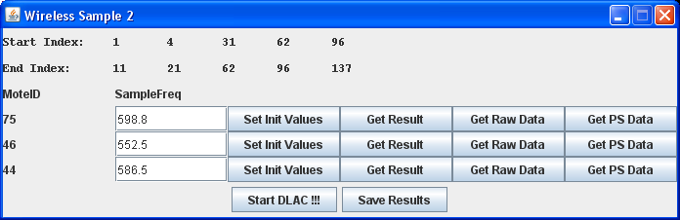
- Ensure that the start and end indices as shown on the top of the user interface are correct.
- Ensure that the sampling frequency of each mote is correct.
- Hit the “Set Init Values” of each mote. Observe the green LED blinking on the mote.
- Hit the “Start DLAC !!!” button.
  - You will see the blue LED blink 6 times, pause, and then blink 6 times again. It will repeat this each time it takes a set of accelerometer readings.
  - Once it is done performing the root calculation, it will turn on the green LED.
  - You must wait for the green LED to turn on before continuing!
  - The red LED will blink if an error condition has occurred.
- Once the green LED has turned on, you can hit the “Get Result” button on each mote, which will retrieve the root calculations.
- To validate, you can also click the “Get Raw Data” button on each mote, which will grab the raw sensor readings.
- The Get PS Data will return a portion of the power spectrum data for validation purposes.
- Click on “Save Results” to save the data to a file. Note the command line output to see where the files are saved.

Control Knobs

Sampling Frequencies
The sampling frequency of each mote is specified in $TOSROOT/apps/WS2/java/ws2.properties. The "motes" value is a comma-separated list of all the Mote IDs in hexadecimal notation (they are the last two digits of the motes' label). The "frequencies" value is a comma-separated list of the motes' corresponding sampling frequencies (in Hz).

Start and End Indices
The start and end indices are also specified in $TOSROOT/apps/WS2/java/ws2.properties. The "start" and "end" values contain 5 comma-separated columns. The "start" value specifies the start indices and the "end" value specifies the end indices.

Number of Samples to Average
- Open $TOSROOT/apps/WS2/ControllerP.nc and edit NUM_AVG on line 37.
- You must re-compile and re-upload WS2 onto the motes for this to take effect.

Wait Interval Between Samples
- Open $TOSROOT/apps/WS2/ControllerP.nc and edit AVG_WAIT on line 39.
- The value is in binary milliseconds (1024 = 1s).
- The default value is 1024.
- You must re-compile and re-upload WS2 onto the motes for this to take effect.

LED Behavior
- WS2 rapidly blinks the blue LED 6 times every time it starts taking a set of raw accelerometer readings.
- WS2 turns on the green LED when it is done taking the samples, averaging the power spectrum, and calculating the roots.
- WS2 blinks the red LED whenever an error has occurred

